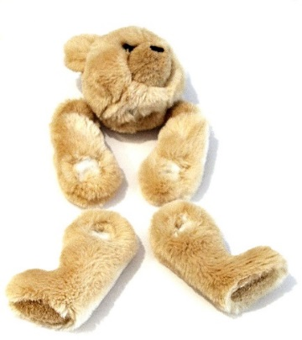Dexter’s Teddy Bear Collection

Design tools used to represent the appearance and function of a DBMS

Dexter loves teddy bears. In fact he owns 10 teddy bears, but some of the teddy bears are old and need some repairs.

Dexter has created a list of all of his teddy bears including the name of the business that made each teddy bear (manufacturer).

He is planning to contact each business to ask if they will be able to repair his teddy bears.

**Additional information**

* Each bear has a unique name
* Each bear is classified into one of three sizes; small, medium and large
* A teddy bear can only have one manufacturer
* A manufacturer can make many bears
* All bears have been purchased since 1993

**Teddy bear data**

|  |  |  |  |  |  |  |
| --- | --- | --- | --- | --- | --- | --- |
| **BearName** | **Colour** | **Size** | **YearPurchased** | **Manufacturer** | **Country** | **NeedRepair?** |
| Mr Bear | Brown | Large | 2008 | Steiff Teddy Bears | Germany | Yes |
| Grizzlee | Purple | Medium | 1993 | Bukowski Design | Sweden | Yes |
| Pookie | Pink | Small | 2011 | Isabelle Collection | United Kingdom | No |
| Cuddles | Cream | Large | 2006 | Hansa Creation | Germany | Yes |
| Claws | Brown | Medium | 1994 | Bear Essentials | Ireland | No |
| Rawr | Yellow | Small | 2016 | Steiff Teddy Bears | Germany | Yes |
| Fuzzy Wuzzy | Brown | Large | 2000 | Bukowski Design | Sweden | No |
| Baloo | Purple | Medium | 1995 | Isabelle Collection | United Kingdom | No |
| Ted | Pink | Small | 2009 | Hansa Creation | Germany | Yes |
| Winnie | Cream | Large | 1998 | Bear Essentials | Ireland | No |

**Design**

**1. Create** an entity-relationship (ER) diagram of the proposed relational database. **Indicate** the types of relationship between the entities.

**2. Create** a data dictionary for each table.

Indicate:

* the name of each table
* the name of each field
* the data type of each field
* the field size (if short text)
* any other properties including primary and foreign keys or any validation used

|  |  |  |  |
| --- | --- | --- | --- |
| **Field** | **Data type** | **Field Size**  **(if short text)** | **Other properties** |
|  |  |  |  |
|  |  |  |  |
|  |  |  |  |
|  |  |  |  |
|  |  |  |  |
|  |  |  |  |
|  |  |  |  |

|  |  |  |  |
| --- | --- | --- | --- |
| **Field** | **Data type** | **Field Size**  **(if short text)** | **Other properties** |
|  |  |  |  |
|  |  |  |  |
|  |  |  |  |
|  |  |  |  |
|  |  |  |  |
|  |  |  |  |
|  |  |  |  |

**3. Create** a layout diagram showing how all forms relevant to the DBMS solution will appear.

**4. Create** a design for each query required to retrieve the following information.

1. A list of bear details sorted by bear name from A to Z.
2. Manufactures’ details sorted by country from Z to A.
3. A list of bears purchased before 2005.
4. A list of bears and manufacturers’ details for bears purchased between 2000 and 2010.
5. The number of bears manufactured in each country.
6. The total number of bears owned by Dexter.